Descriptive Statistics
 | Mean | Std. Deviation | N
Perlakuan | 2,00 | ,832 | 27
Hasil | 439,52 | 65,996 | 27

Correlations
 |  | Perlakuan | Hasil
Pearson Correlation | Perlakuan | 1,000 | ,388
Pearson Correlation | Hasil | ,388 | 1,000
Sig. (1-tailed) | Perlakuan | . | ,023
Sig. (1-tailed) | Hasil | ,023 | .
N | Perlakuan | 27 | 27
N | Hasil | 27 | 27

Variables Entered/Removedª
Model | Variables Entered | Variables Removed | Method
1 | Hasil^{b} | . | Enter

a. Dependent Variable: Perlakuan
b. All requested variables entered.

Model Summary^{b}
Model | R | R Square | Adjusted R Square | Std. Error of the Estimate | Change Statistics
 |  |  |  |  | R Square Change | F Change
1 | ,388ª | ,151 | ,117 | ,782 | ,151 | 4,431

Model Summary^{b}
Model | Change Statistics
Model | df1 | df2 | Sig. F Change
1 | 1 | 25 | ,045 | ,337

a. Predictors: (Constant), Hasil
b. Dependent Variable: Perlakuan

ANOVAª
Model |  | Sum of Squares | df | Mean Square | F | Sig.
1 | Regression | 2,710 | 1 | 2,710 | 4,431 | ,045^{b}
1 | Residual | 15,290 | 25 | ,612
1 | Total | 18,000 | 26

a. Dependent Variable: Perlakuan
b. Predictors: (Constant), Hasil

Coefficientsª
Model |  | Unstandardized Coefficients |  | Standardized Coefficients | t | Sig.
 |  | B | Std. Error | Beta | t | Sig.
1 | (Constant) | -,150 | 1,032 |  | -,145 | ,886
1 | Hasil | ,005 | ,002 | ,388 | 2,105 | ,045

Coefficientsª
Model |  | Collinearity Statistics
 |  | Tolerance | VIF
1 | (Constant)
1 | Hasil | 1,000 | 1,000

a. Dependent Variable: Perlakuan

Collinearity Diagnosticsª
Model | Dimension | Eigenvalue | Condition Index | Variance Proportions
 |  |  |  | (Constant) | Hasil
1 | 1 | 1,989 | 1,000 | ,01 | ,01
1 | 2 | ,011 | 13,647 | ,99 | ,99

a. Dependent Variable: Perlakuan

Residuals Statisticsª
 | Minimum | Maximum | Mean | Std. Deviation | N
Predicted Value | 1,34 | 2,58 | 2,00 | ,323 | 27
Residual | -1,012 | 1,389 | ,000 | ,767 | 27
Std. Predicted Value | -2,053 | 1,795 | ,000 | 1,000 | 27
Std. Residual | -1,294 | 1,776 | ,000 | ,981 | 27

a. Dependent Variable: Perlakuan

Charts

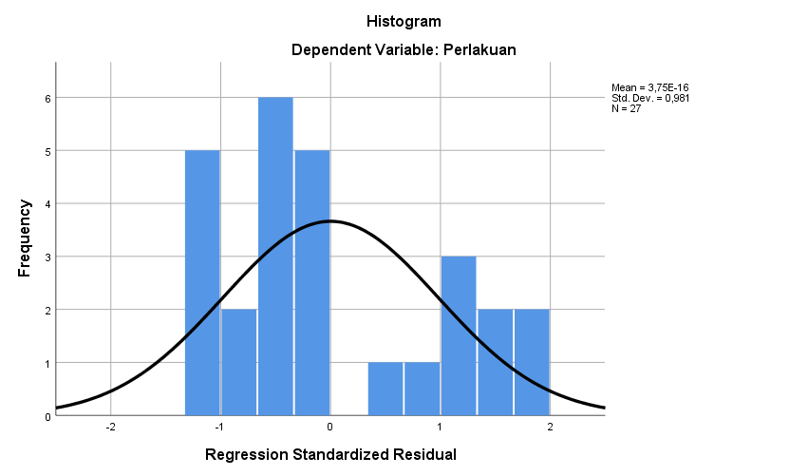

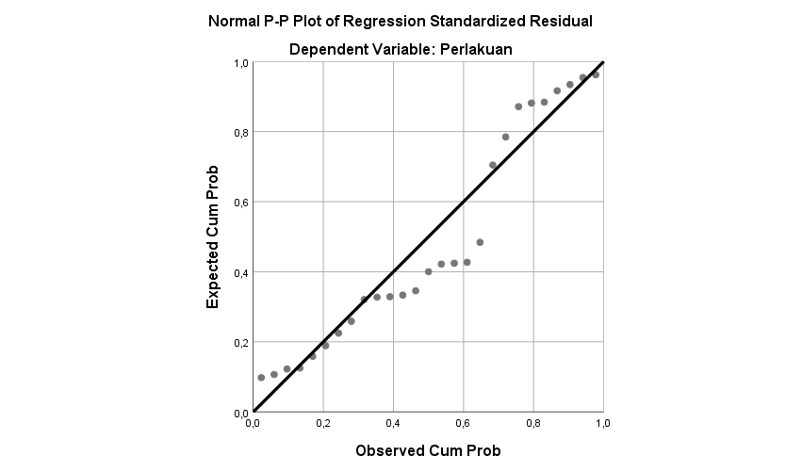

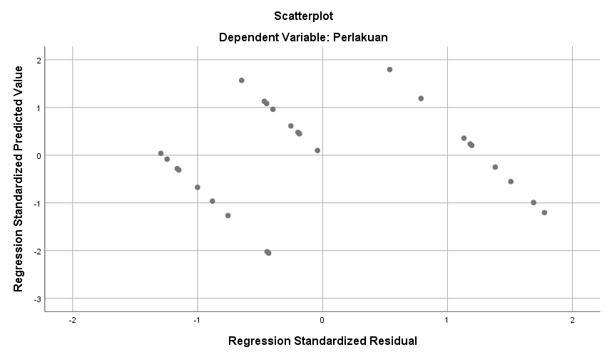
Case Processing Summary
 | Cases
 | Valid |  | Missing |  | Total
 | N | Percent | N | Percent | N | Percent
Perlakuan * Hasil | 27 | 100,0% | 0 | 0,0% | 27 | 100,0%

Perlakuan * Hasil Crosstabulation
Count
 |  | Hasil
 |  | 304 | 306 | 356 | 360 | 374 | 376 | 395
Perlakuan | 1 | 1 | 1 | 1 | 0 | 0 | 1 | 1
Perlakuan | 2 | 0 | 0 | 0 | 0 | 0 | 0 | 0
Perlakuan | 3 | 0 | 0 | 0 | 1 | 1 | 0 | 0
Total |  | 1 | 1 | 1 | 1 | 1 | 1 | 1

Perlakuan * Hasil Crosstabulation
Count
 |  | Hasil
 |  | 403 | 419 | 421 | 423 | 434 | 442 | 446
Perlakuan | 1 | 0 | 1 | 1 | 0 | 1 | 1 | 0
Perlakuan | 2 | 0 | 0 | 0 | 0 | 0 | 0 | 1
Perlakuan | 3 | 1 | 0 | 0 | 1 | 0 | 0 | 0
Total |  | 1 | 1 | 1 | 1 | 1 | 1 | 1

Perlakuan * Hasil Crosstabulation
Count
 |  | Hasil
 |  | 453 | 455 | 463 | 469 | 470 | 471 | 480
Perlakuan | 1 | 0 | 0 | 0 | 0 | 0 | 0 | 0
Perlakuan | 2 | 0 | 0 | 0 | 1 | 1 | 1 | 1
Perlakuan | 3 | 1 | 1 | 1 | 0 | 0 | 0 | 0
Total |  | 1 | 1 | 1 | 1 | 1 | 1 | 1

Perlakuan * Hasil Crosstabulation
Count
 |  | Hasil
 |  | 503 | 511 | 514 | 518 | 543 | 558
Perlakuan | 1 | 0 | 0 | 0 | 0 | 0 | 0 | 9
Perlakuan | 2 | 1 | 1 | 1 | 0 | 1 | 0 | 9
Perlakuan | 3 | 0 | 0 | 0 | 1 | 0 | 1 | 9
Total |  | 1 | 1 | 1 | 1 | 1 | 1 | 27

Symmetric Measures
 |  | Value | Asymptotic Standard Errorª | Approximate T^{b}
Interval by Interval | Pearson's R | ,388 | ,155 | 2,105
Ordinal by Ordinal | Spearman Correlation | ,379 | ,191 | 2,045
N of Valid Cases |  | 27

Symmetric Measures
 |  | Approximate Significance
Interval by Interval | Pearson's R | ,045^{c}
Ordinal by Ordinal | Spearman Correlation | ,052^{c}
N of Valid Cases

a. Not assuming the null hypothesis.
b. Using the asymptotic standard error assuming the null hypothesis.
c. Based on normal approximation.

Berdasarkan hasil analisis deskriptif, diperoleh rata-rata variabel perlakuan sebesar 2,00 dan variabel hasil sebesar 439,52 dengan jumlah sampel 27 data. Hasil uji korelasi Pearson menunjukkan adanya hubungan positif antara perlakuan dan hasil dengan nilai korelasi sebesar 0,388 dan signifikansi 0,045 (<0,05). Hal ini menunjukkan bahwa perlakuan memiliki hubungan yang signifikan terhadap hasil penelitian, meskipun tingkat hubungannya tergolong rendah hingga sedang.

Hasil analisis regresi linear sederhana menunjukkan nilai R Square sebesar 0,151, yang berarti variabel hasil mampu menjelaskan pengaruh terhadap perlakuan sebesar 15,1%, sedangkan sisanya dipengaruhi faktor lain di luar penelitian. Uji ANOVA menunjukkan nilai F sebesar 4,431 dengan signifikansi 0,045, sehingga model regresi dinyatakan signifikan dan layak digunakan.

Persamaan regresi yang diperoleh adalah:

Y=−0,150+0,005X

Koefisien regresi bernilai positif, sehingga menunjukkan bahwa peningkatan nilai hasil cenderung diikuti peningkatan nilai perlakuan. Selain itu, nilai tolerance dan VIF masing-masing sebesar 1,000 menunjukkan tidak terdapat gejala multikolinearitas pada model penelitian.

